**VIVEKANANDA INSTITUTE OF PROFESSIONAL STUDIES - TECHNICAL CAMPUS**

# Grade A++ Accredited Institution by NAAC

NBA Accredited for MCA Programme; Recognized under Section 2(f) by UGC;

Affiliated to GGSIP University, Delhi; Recognized by Bar Council of India and AICTE An ISO 9001:2015 Certified Institution

**SCHOOL OF ENGINEERING & TECHNOLOGY**

**B.Tech Programme: Computer Science & Engineering**

# Course Title: Software Engineering Lab

**Course Code: CIC-357**

**Semester: 5th**

**Submitted By**

**Name: Kailash rawat**

**Enrollment No: 09217702722**

**Branch & Section: CSE-B (G2)**

## VISION OF INSTITUTE

To be an educational institute that empowers the field of engineering to build a sustainable future by providing quality education with innovative practices that supports people, planet and profit.

## MISSION OF INSTITUTE

To groom the future engineers by providing value-based education and awakening students' curiosity, nurturing creativity and building capabilities to enable them to make significant contributions to the world.

**INDEX**

|  |  |  |  |  |  |  |  |  |
| --- | --- | --- | --- | --- | --- | --- | --- | --- |
| **S.No** | **EXP.** | **Date** | **Marks** |  | | **Remark** | **Update d** | **Faculty** |
|  |  |  |  |  | |  | **Marks** | **Signature** |
| **Laboratory** | **Class** | **Viva** |  |  |  |
|  |  |  | **Assessment** | **Participation** | **(5 Marks)** |  |  |  |
|  |  |  | **(15 Marks)** | **(5 Marks)** |  |  |  |  |
|  |  |  |  |  |  |  |  |  |
|  |  |  |  |  |  |  |  |  |
|  |  |  |  |  |  |  |  |  |
|  |  |  |  |  |  |  |  |  |

**INDEX**

|  |  |  |  |  |  |  |  |  |
| --- | --- | --- | --- | --- | --- | --- | --- | --- |
| **S.No** | **EXP.** | **Date** | **Marks** |  | | **Remark** | **Update d** | **Faculty** |
|  |  |  |  |  | |  | **Marks** | **Signature** |
| **Laboratory** | **Class** | **Viva** |  |  |  |
|  |  |  | **Assessment** | **Participation** | **(5 Marks)** |  |  |  |
|  |  |  | **(15 Marks)** | **(5 Marks)** |  |  |  |  |
|  |  |  |  |  |  |  |  |  |
|  |  |  |  |  |  |  |  |  |
|  |  |  |  |  |  |  |  |  |
|  |  |  |  |  |  |  |  |  |

# Experiment 1

**AIM: Write down the problem statement for a Online hospital management system.**

**Problem Statement:**

# Experiment 2

**AIM: Do requirement analysis and develop Software Requirement Specification Sheet (SRS) for online hospital management system .**

**Theory:**

# Experiment 3

**AIM: To perform the function oriented diagram: Data Flow Diagram (DFD)**

**Theory:**

**Procedure:**

**Output:**

**DFD(LEVEL 0):**

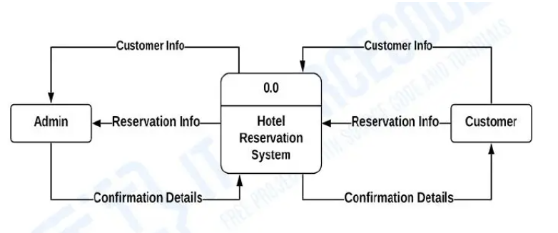

**DFD(LEVEL 1):**

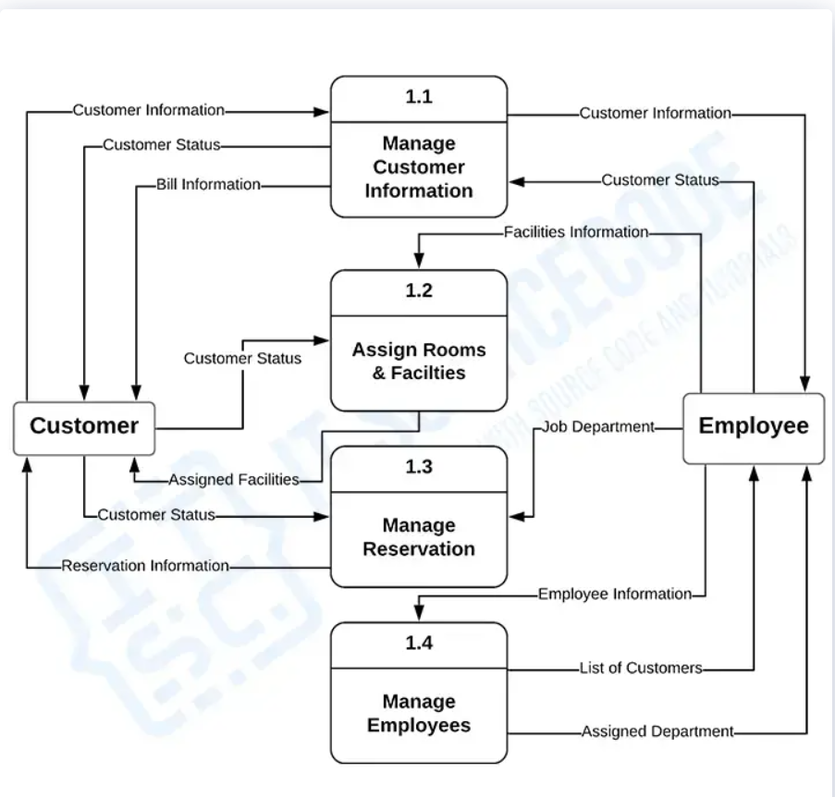

**DFD(LEVEL 2):** 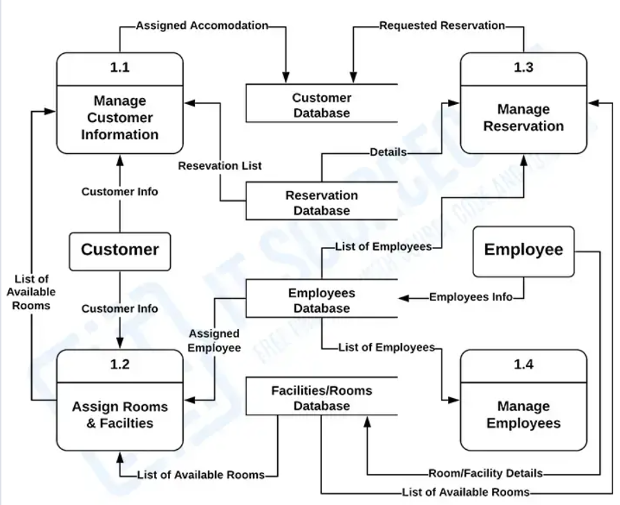

**Learning Outcomes:**

# Experiment 4

**AIM: Draw the entity relationship diagram for the online hospital management system.**

**Theory:**

**Procedure:**

**Output:**

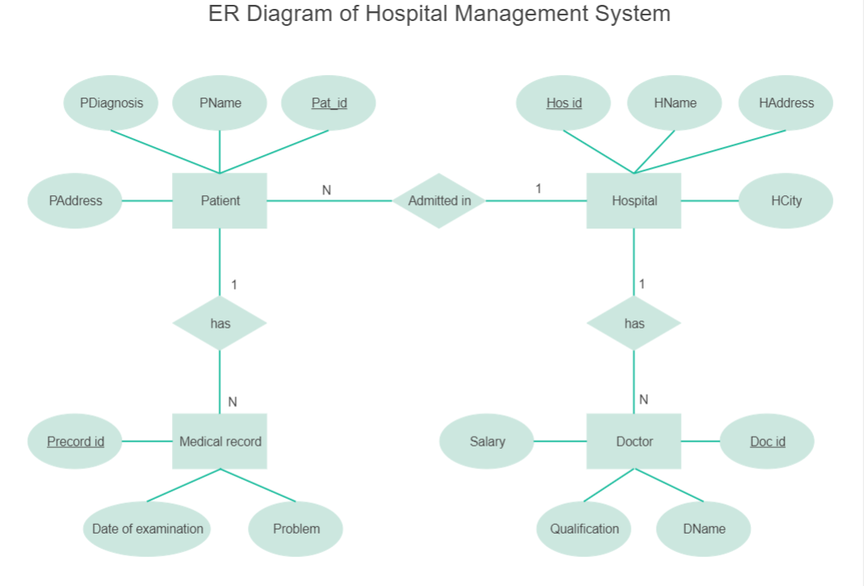

**Learning Outcomes:**

# Experiment 5

**AIM: To perform the user’s view analysis for the Online hospital management system. Use case Diagram.**

**Theory:**

**Procedure:**

**Output:**

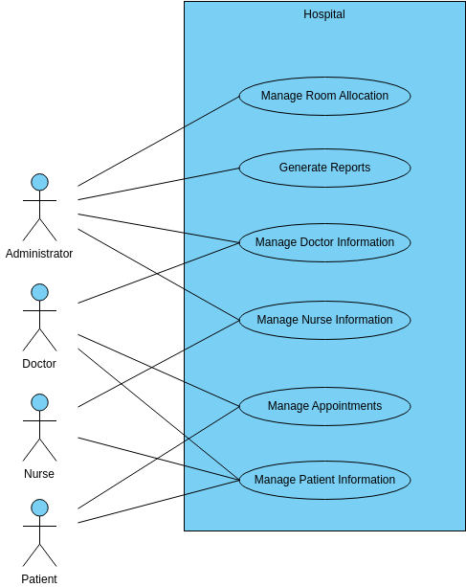

**Learning Outcomes:**

# Experiment 6

**AIM: To draw structural view diagrams for the online hospital management system: Class diagram, Object diagram.**

**Theory:**

**Procedure:**

**Output:**

**CLASS DIAGRAM:**

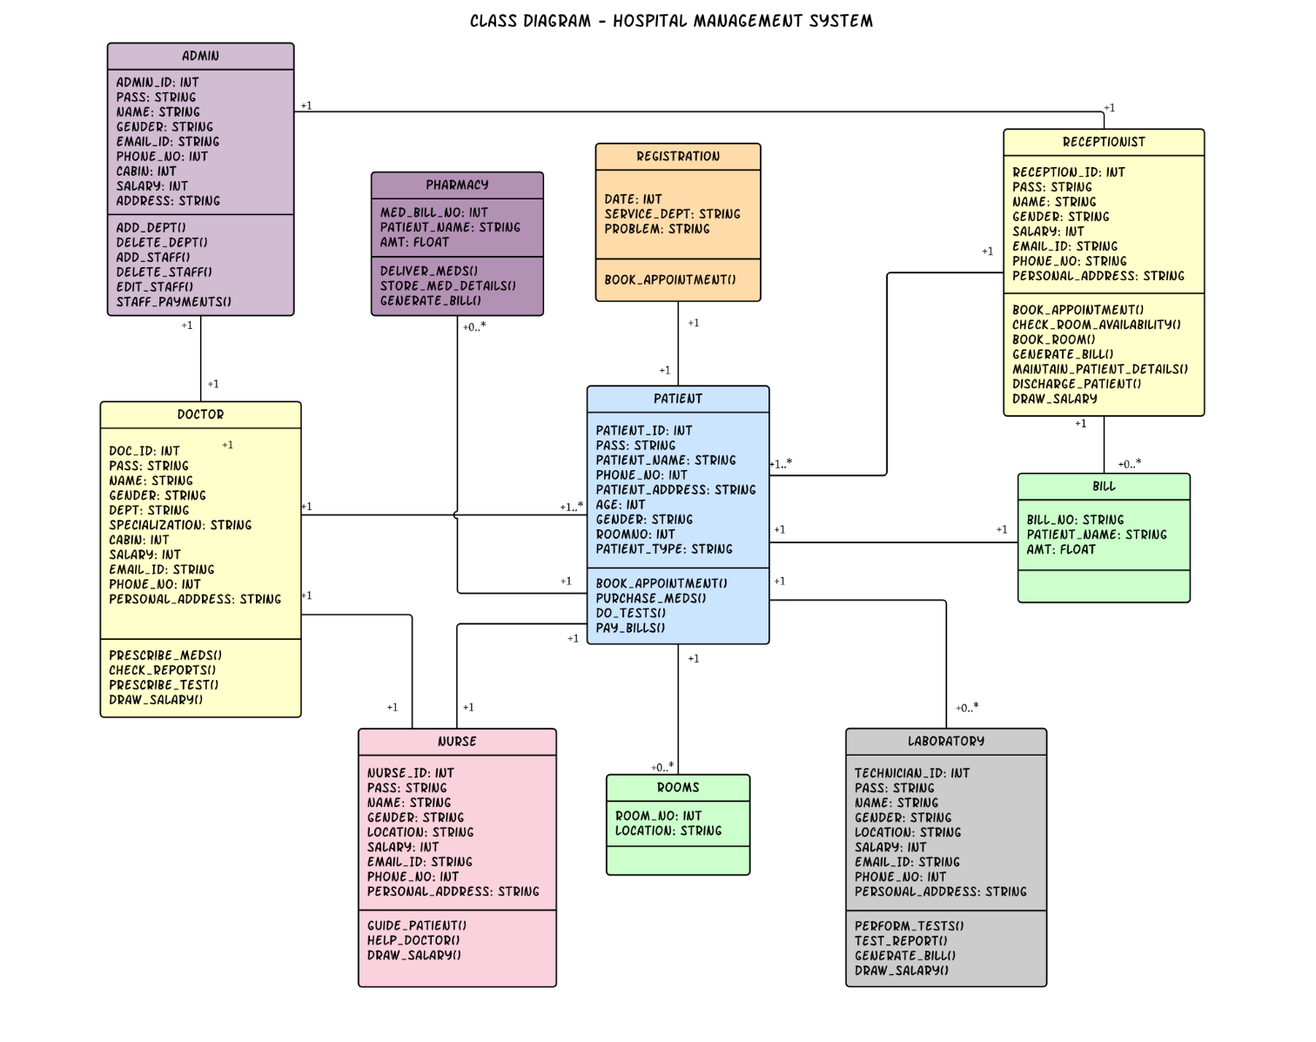

**OBJECT DIAGRAM:**

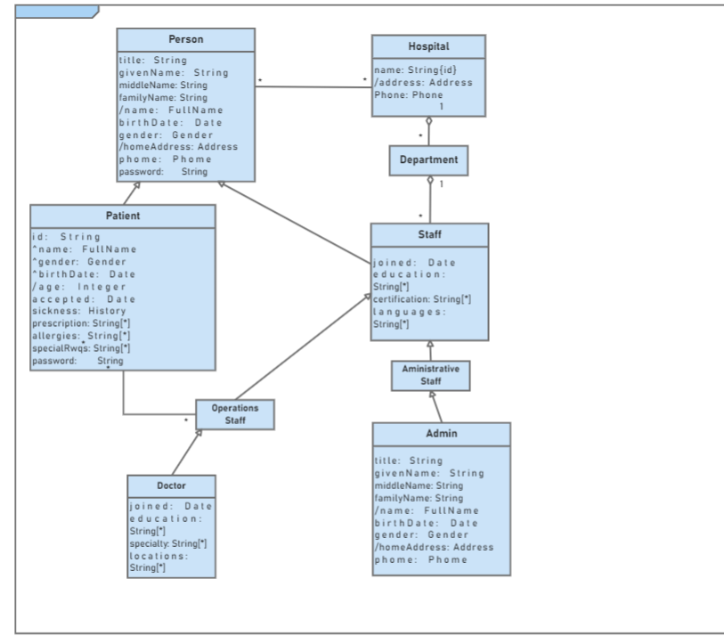

**Learning Outcomes:**

# Experiment 7

**AIM: To draw the behavioral view diagram: State Chart Diagram, Activity Diagram**

**Theory:**

**Procedure:**

**Output:**

**STATE CHART DIAGRAM:**

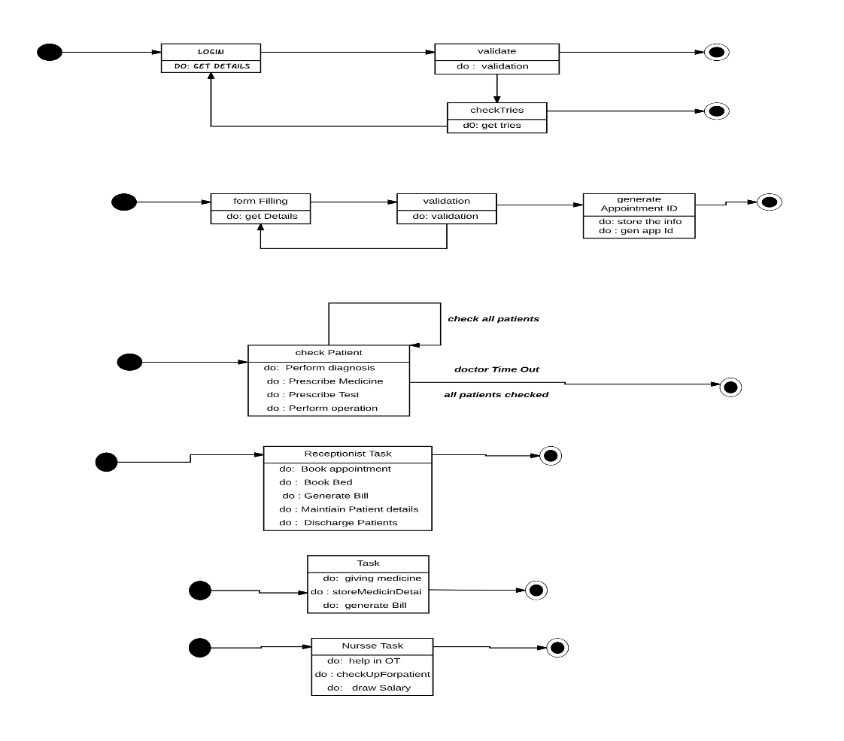

**ACTIVITY DIAGRAM:**

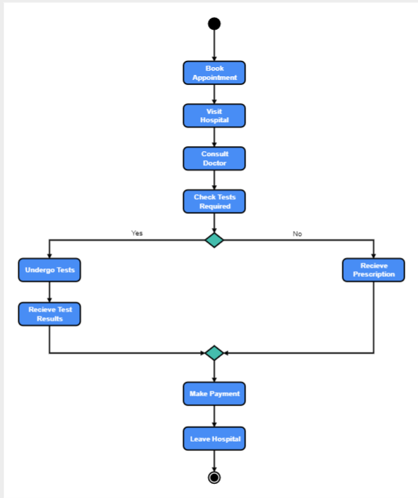**Learning Outcomes:**

# Experiment 8

**AIM: To perform the behavioral view diagram for the online hospital management system: Sequence Diagram,**

**Theory:**

**Procedure:**

**Output:**

**SEQUENCE DIAGRAM:**

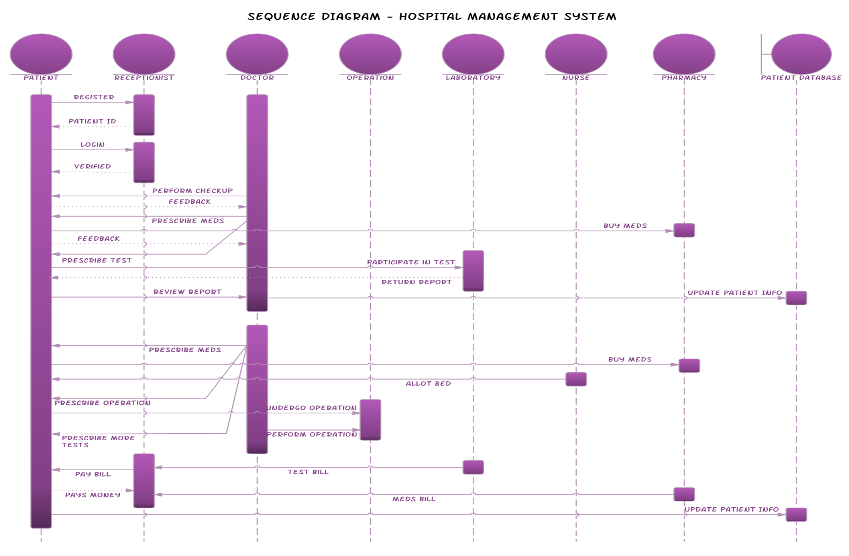

**COLLABORATION DIAGRAM:**

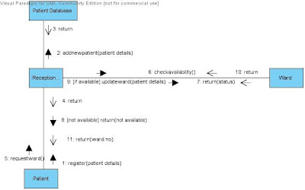

**Learning Outcomes:**

# Experiment 9

**AIM: To perform the implementation view diagram: Component Diagram for online hospital management system.**

**Theory:**

**Procedure:**

**Output:** 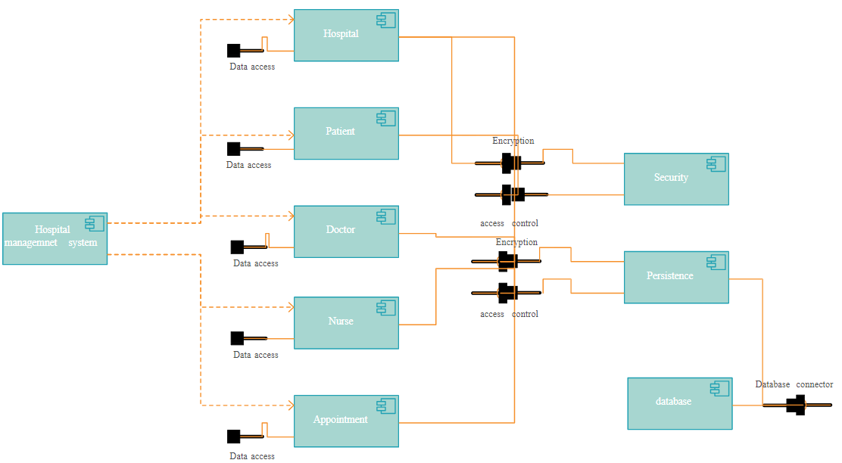

**Learning Outcomes:**

# Experiment 10

**AIM: To perform the environmental view diagram: Deployment Diagram for online hospital management system.**

**Theory:**

**Procedure:**

**Output:**

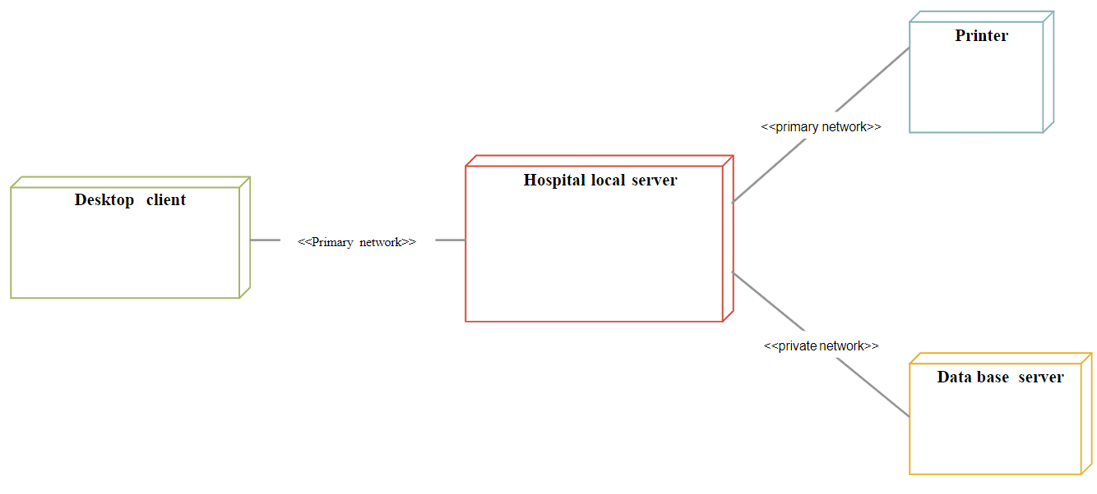

**Learning Outcomes:**